**Aritjon: Hydraulic Inventory Management**

Aritjon is an inventory management software crafted for businesses specializing in hydraulic materials, pipes, and accessories. This software redefines how businesses streamline their operations, ensuring optimal stock levels, efficient order processing, and seamless tracking of hydraulic products within warehouses.

### **User Requirements:**

* **Intuitive Dashboard:**
  + The system should present users with an intuitive and easy-to-navigate dashboard.
  + Key information, such as stock levels and alerts, should be prominently displayed.
* **Real-Time Tracking:**
  + Users should be able to track the real-time location of specific hydraulic products within the warehouse.
  + Tracking information should be easily accessible from the user interface.
* **Alerts and Notifications:**
  + The system should provide timely alerts and notifications, especially for low stock levels of popular hydraulic materials, pipes, and accessories.
  + Alerts should be clear, actionable, and customizable.
* **Order Management:**
  + Users should be able to create and manage purchase orders for hydraulic products.
  + The order management process should be intuitive, allowing for quick updates and tracking.
* **Supplier Interaction:**
  + Users should have the ability to view and interact with supplier information relevant to hydraulic materials, pipes, and accessories.
  + Contact details, performance metrics, and historical data should be easily accessible.
* **Product Details:**
  + Comprehensive details about each hydraulic product, including specifications, compatibility information, and pricing, should be available.
  + Users should be able to view detailed product information with a single click.
* **Returns and Refunds:**
  + Users should be able to initiate and track returns for hydraulic materials, pipes, and accessories.
  + The returns process should be clear and include relevant information about the return status.
* **Reporting and Analytics:**
  + Users should have access to customizable reports and analytics specific to hydraulic products.
  + Reports should provide insights into inventory turnover, product demand, and other relevant metrics.
* **Mobile Accessibility:**
  + The system should be accessible via mobile devices, allowing users to perform key functions on-the-go.
  + Mobile interfaces should be responsive and optimized for smaller screens.
* **Feedback and Support:**
  + Users should have the ability to provide feedback on the system.
  + Support features, such as live chat or helpdesk functionality, should be available for assistance.
* **User Training and Resources:**
  + The system should provide user training resources, tutorials, and documentation.
  + Help features and tooltips should be available within the system for quick assistance.
* **Accessibility Features:**
  + The system should adhere to accessibility standards to accommodate users with different abilities.
  + Consideration should be given to features such as text-to-speech, keyboard navigation, and color contrast.
* **Customization:**
  + Users should have the ability to customize their view of the dashboard and reports.
  + Customizable settings should be intuitive and easy to configure.

### **Functional Requirements:**

* **Hydraulic Materials Database:**
  + The system shall maintain a centralized database for hydraulic materials, pipes, and accessories.
  + Each entry shall include detailed specifications, sizes, and compatibility information.
* **Location Tracking:**
  + The system shall provide real-time tracking of the location of each hydraulic product using barcode or RFID technology.
* **Stock Level Monitoring:**
  + The system shall generate automatic alerts for low stock levels, specifically for popular hydraulic materials, pipes, and accessories.
* **Order Management:**
  + The system shall allow users to create and manage purchase orders for restocking hydraulic products.
  + Users shall be able to track the status of incoming orders and update stock levels accordingly.
* **Supplier Management:**
  + The system shall maintain a supplier database specific to hydraulic materials, pipes, and accessories.
  + Users shall be able to track supplier performance, lead times, and pricing for these specific product categories.
* **Multi-Warehouse Support:**
  + If applicable, the system shall support multiple warehouses and allow users to track inventory levels specifically for hydraulic products.
* **Demand Forecasting for Hydraulic Products:**
  + The system shall utilize historical data to predict demand specifically for hydraulic materials, pipes, and accessories.
* **User Permissions for Hydraulic Inventory:**
  + The system shall implement role-based access control with user roles tailored to managing hydraulic product inventory.
* **Returns Management for Hydraulic Products:**
  + The system shall facilitate the tracking and management of returns for hydraulic materials, pipes, and accessories.
* **Integration with E-commerce Platforms for Hydraulic Sales:**
  + The system shall integrate with the business's e-commerce platform to automatically update inventory levels for hydraulic products after sales.
* **Inventory Valuation for Hydraulic Inventory:**
  + The system shall implement different valuation methods (FIFO, LIFO, etc.) specific to hydraulic materials, pipes, and accessories.
* **Serialized Inventory for Specific Products:**
  + The system shall manage serialized items for hydraulic materials, pipes, and accessories with unique identifiers.
* **Reporting and Analytics for Hydraulic Inventory:**
  + The system shall generate customizable reports on various aspects of the inventory, specifically focusing on hydraulic products.
* **Mobile Accessibility for Hydraulic Inventory:**
  + The system shall allow users to access the inventory management system via mobile devices, specifically for hydraulic materials, pipes, and accessories.
  + Barcode scanning using mobile devices shall be enabled for quick updates.
* **Automated Reordering for Hydraulic Products:**
  + The system shall support automated reordering based on predefined reorder points and lead times for hydraulic materials, pipes, and accessories.
* **Expiry Date Tracking for Hydraulic Materials:**
  + If applicable, the system shall implement features to track expiration dates and manage stock rotation for hydraulic materials.
* **Kitting and Bundling for Accessories:**
  + The system shall support the creation and management of accessory kits or bundles specifically for hydraulic materials.
  + It shall track individual components and their collective stock levels.
* **Batch Tracking for Hydraulic Materials:**
  + The system shall track hydraulic materials by batches, especially useful for industries with stringent quality control requirements.

### **Non-Functional Requirements:**

* **Performance:**
  + The system shall provide fast response times for tracking and updating hydraulic product information.
  + It shall handle a large volume of transactions without significant degradation in performance.
* **Scalability:**
  + The system shall be scalable to accommodate the growth of inventory and the addition of new hydraulic products.
  + It should support increased user and transaction loads.
* **Security:**
  + The system shall ensure the security of user data, especially sensitive information related to hydraulic products.
  + Access to the system shall be controlled through secure authentication methods.
* **Compatibility:**
  + The system shall be compatible with commonly used web browsers and mobile devices.
  + It shall integrate seamlessly with existing hardware and software systems.
* **Reliability:**
  + The system shall be available and reliable, with minimal downtime for maintenance.
  + Backup and recovery mechanisms shall be in place to prevent data loss.
* **Usability:**
  + The system shall have an intuitive and user-friendly interface tailored to managing hydraulic products.
  + Training requirements for users shall be minimal.
* **Regulatory Compliance:**
  + The system shall comply with relevant data protection and privacy regulations.
  + It shall adhere to industry standards for inventory management in the sale of hydraulic materials.
* **Audit Trail:**
  + The system shall maintain a detailed audit trail of inventory transactions specific to hydraulic materials, pipes, and accessories.
  + It shall log changes to stock levels, user actions, and system modifications.
* **Mobile Accessibility:**
  + The mobile version of the system shall be responsive and provide a consistent user experience.
  + Barcode scanning using mobile devices shall be accurate and efficient.
* **Automated Processes:**
  + Automated processes, such as reordering and alerts, shall function accurately and in a timely manner.
  + Users shall be able to trust the automation features for managing hydraulic inventory.
* **Data Accuracy:**
  + The system shall maintain accurate and up-to-date information about hydraulic materials, pipes, and accessories.
  + Any changes to the inventory shall be reflected in real-time.

UML Diagrams

* Class Diagram

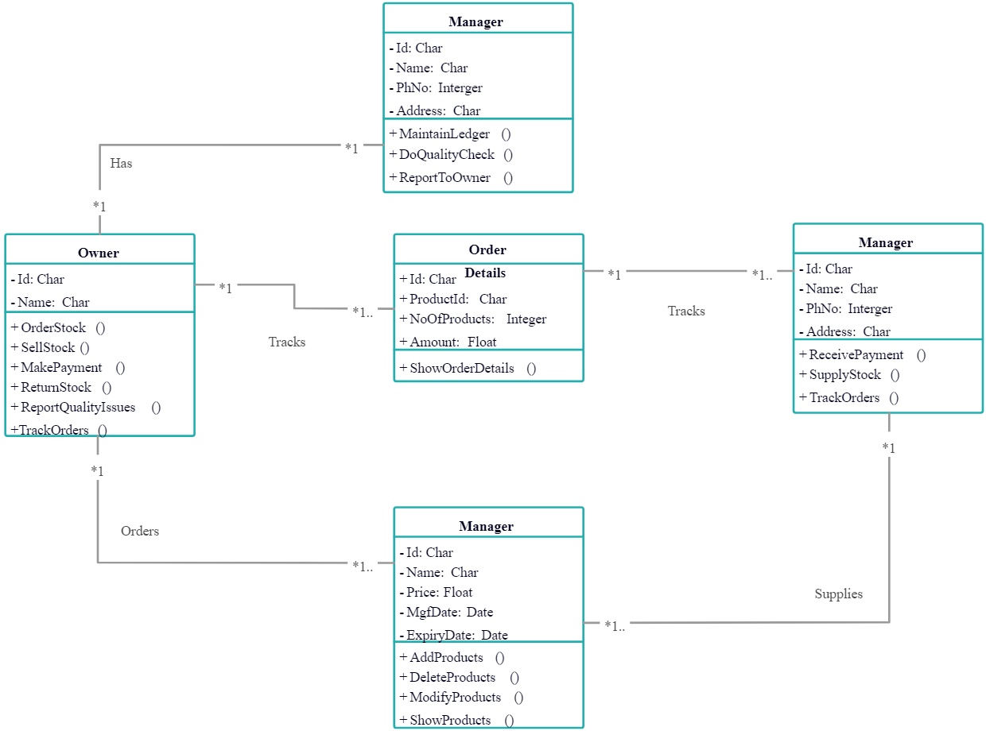

* Object Diagram

